

SPENDWISE

TEAM LEADER:

GOPIKA S M

TEAM MEMBERS:
- DHANALAKSHMI S
- DHANA LEKSHMI S
- BAVANA G
Department: BCA – II Year College:Valliammal College for Women




INTRODUCTION

SpendWise is a backend REST API project developed using Node.js, Express.js, and MongoDB. It allows users to register, log in, and manage their financial transactions securely. The system uses JWT authentication to protect user data, ensuring that only authorized users can access and modify their transactions. The project follows the MVC architecture, which helps organize the code and maintain secure data handling in the application.




TECHNOLOGIES USED

Node.js
A JavaScript runtime environment for building scalable backend applications.

Express.js
A web framework for Node.js, simplifying API development.

MongoDB
A NoSQL database to store application data.

JSON Web Token (JWT)
Used for secure user authentication.




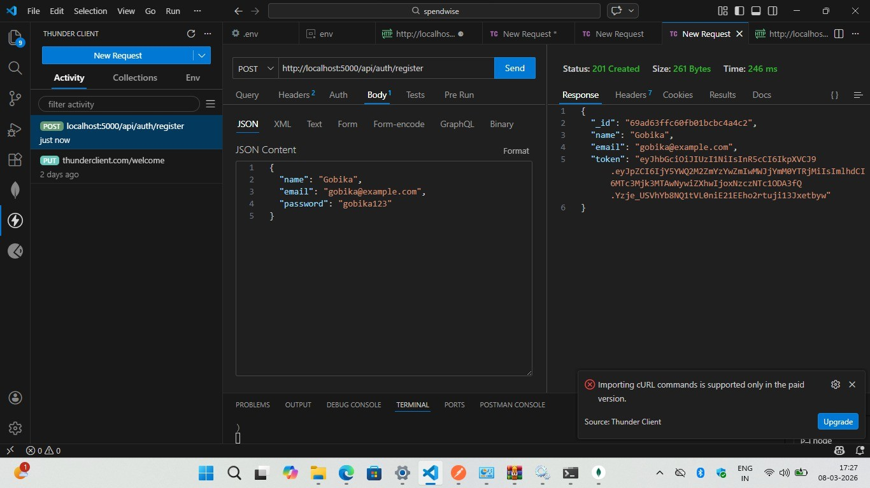






Conclusion
The SpendWise Backend API provides a secure system for managing user transactions. It allows users to register, login, and perform CRUD operations on their financial records.
This project demonstrates the use of Node.js, Express.js, MongoDB, and REST API development in building a secure backend application.

